BOOKING FORM
Name
Contact
Recipient of the gift
(name to be put on the certificate and web page map)
Wording/image engraving  (Should be jpg and in black and white) |  | IMAGE  HERE  Measurement  Width: 2.82 inches (71.5 mm)  Height: 5.78 inches (146.7 mm) | 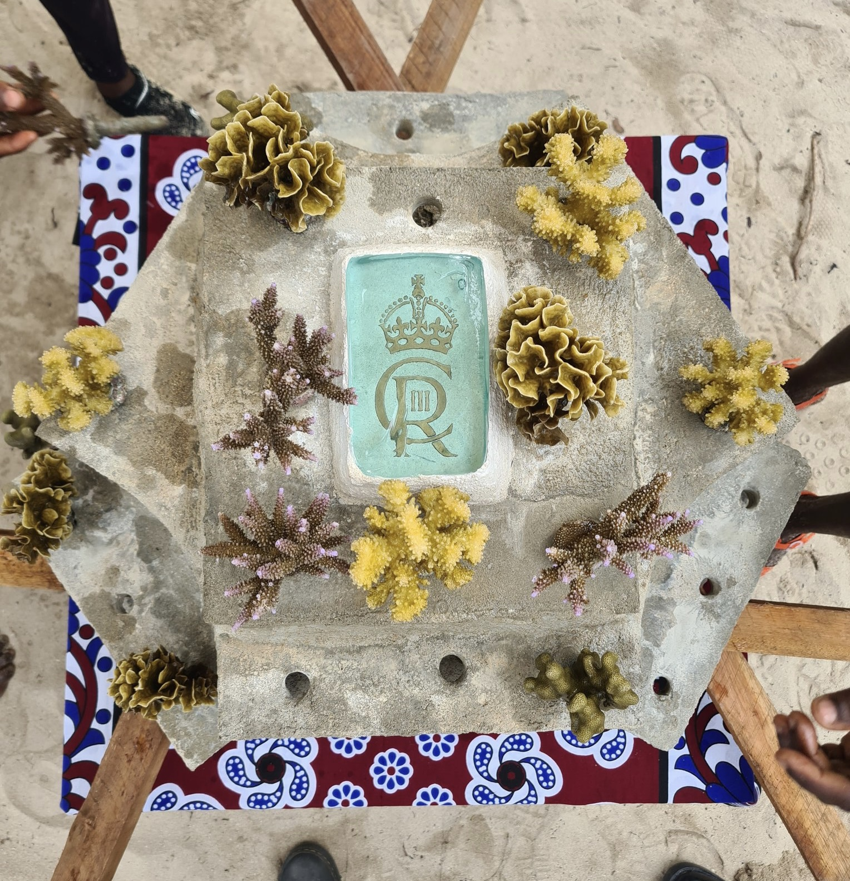  Reference Image
Payment via our PayPal link or bank transfer | Bank Details: GBP Account Name: OCEANS ALIVE TRUST  Account number 3533390031  UK£ Bank NCBA BANK KENYA PLC Bank Code 07000  Swift Code CBAFKENX GBP  Intermediary Bank Details Citibank NA, London CITIGB2L  Pay Pal email : des@oceansalivekenya.org
Note：We will issue your certificate within 10 days, and send you an initial report on the location of your coral structure, including a photo with the glass plaque in place, within 2-weeks of payment.
After filling this form in you may forward it directly to tilda@oceansalivekenya.org
If you have any questions or would like further details, please contact me directly on tilda@oceansalivekenya.org

